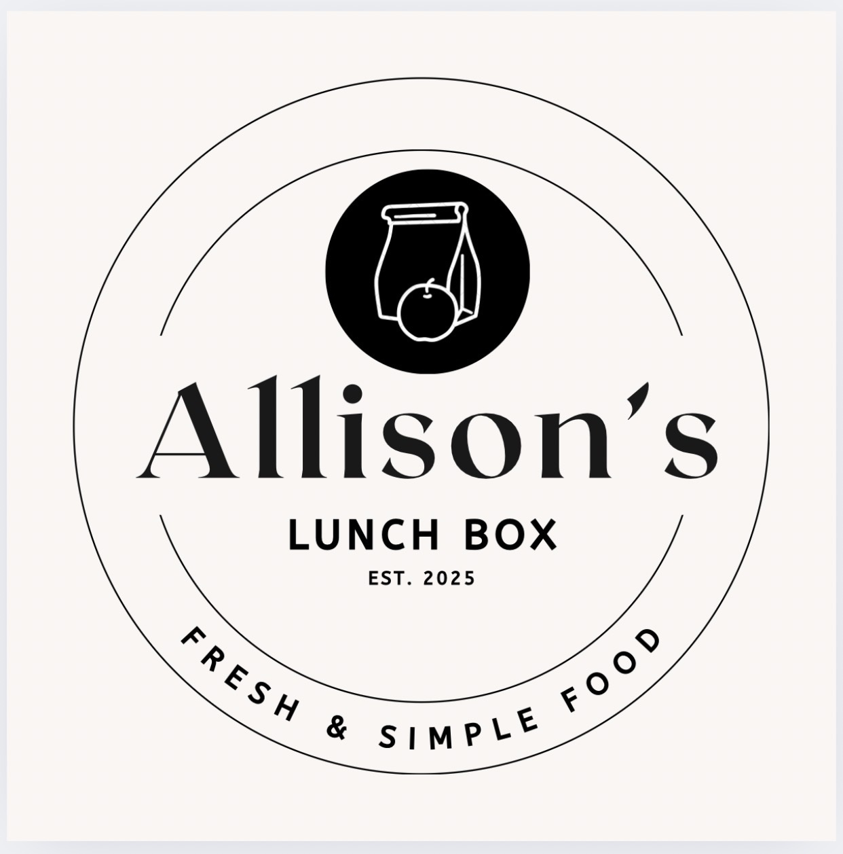
INCLEMENT WEATHER / BUS CANCELLATION POLICY
ALLISON’S LUNCHBOX HOTLUNCH PROGRAM
Allison’s LunchBox is committed to providing reliable Hot Lunch service while recognizing that inclement weather may affect school transportation and student attendance.
BUS CANCELLATIONS
If Ardrossan Elementary School remains open, Hot Lunch will be prepared and served as scheduled, regardless of school bus cancellations.
For example, if buses are cancelled in the morning, afternoon, or for the entire day due to weather or road conditions, the scheduled Hot Lunch service will continue.
STUDENT ABSENCES
If a student does not attend school because of a bus cancellation, weather conditions, or a family’s decision to keep the student home, the regular Absent Student Hot Lunch Policy applies.
NO refunds, credits, or replacement meals will be provided for missed Hot Lunch orders.
LUNCH PICK-UP
Parents/guardians may arrange for a sibling who is attending school to collect the student’s lunch, or a parent/guardian may pick it up from the kitchen service window between 12:00 PM and 1:00 PM.
Parents/guardians coming into the school must enter through the main entrance, report to the school office and sign in as a visitor, collect the lunch from the kitchen service window, and return to the office to sign out before leaving.
UNCLAIMED LUNCHES
Any lunches prepared but not collected during the designated pickup time will be considered forfeited and will not be refunded, credited, or replaced.
Thank you for your understanding and cooperation.
Thank you for your understanding and cooperation. This policy allows Allison’s LunchBox to plan, purchase, and prepare meals efficiently while maintaining consistent Hot Lunch service during inclement weather.

