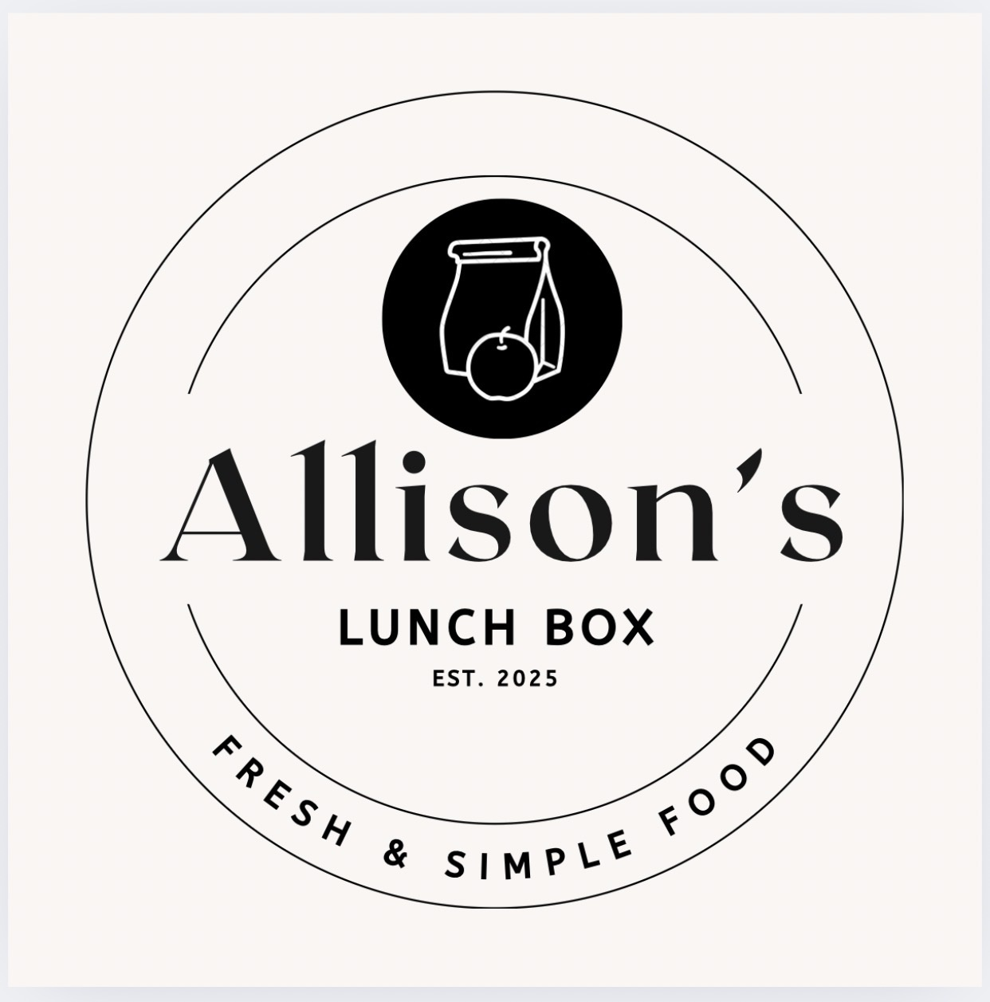
UNCLAIMED HOT LUNCHES POLICY
ALLISON’S LUNCHBOX HOTLUNCH PROGRAM
Allison’s LunchBox has established this policy to clearly outline what happens when a Hot Lunch order is not collected.
UNCLAIMED ORDERS
Any Hot Lunch orders that are not collected by the end of the designated pickup period will be considered unclaimed.
REFUNDS, CREDITS & REPLACEMENTS
No refunds, credits, or replacement meals will be provided for unclaimed Hot Lunch orders.
Allison’s LunchBox • Fresh & Simple Food

